**DISTRIBUTION PLOTS**

DISTRIBUTION PLOTS

sns.distplot(tips['total_bill'],kde=False,bins=30)

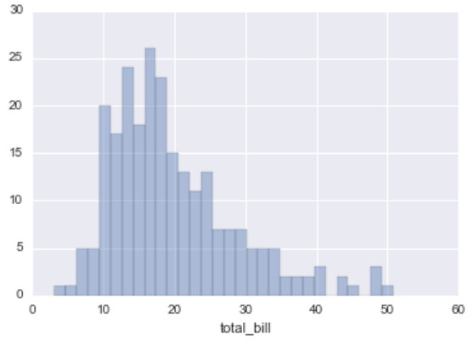

JOINT PLOTS

sns.jointplot(x='total_bill',y='tip',data=tips,kind='scatter')

#kind = scatter, reg, resid, kde, hex

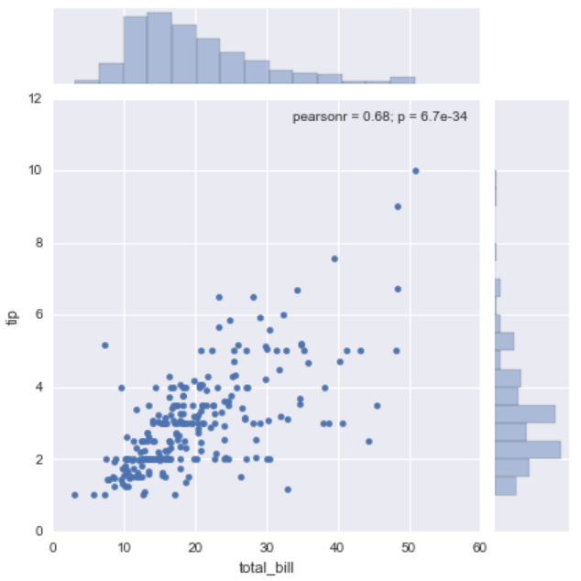

PAIR PLOTS

sns.pairplot(tips,hue='sex',palette='coolwarm')

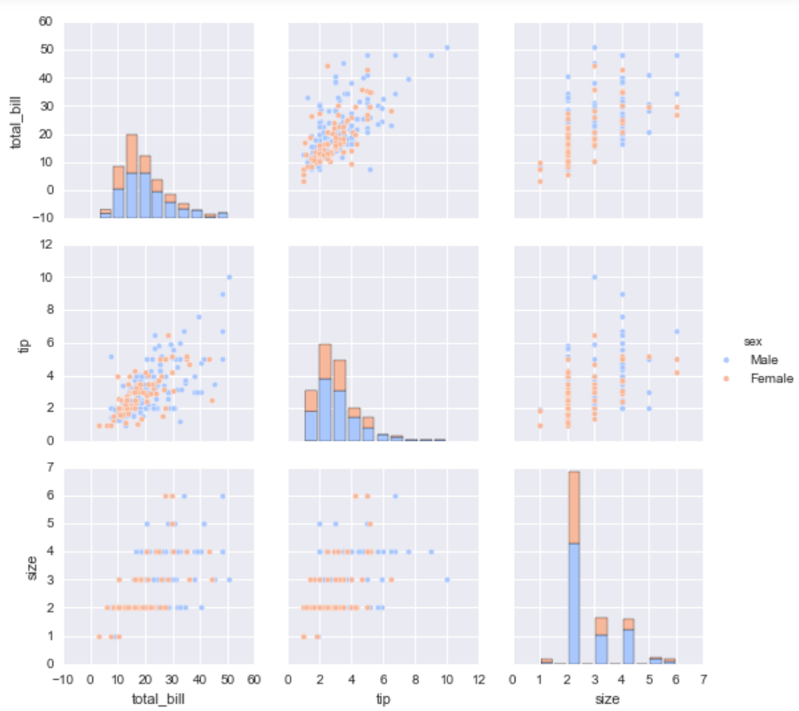

RUG PLOTS

sns.rugplot(tips['total_bill'])

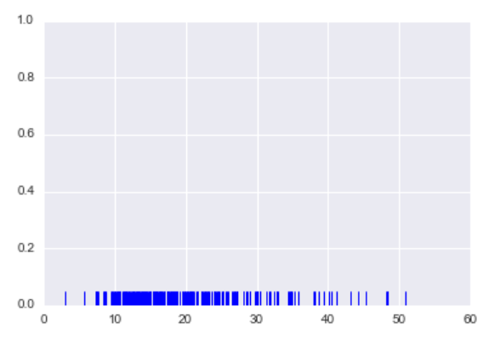

KDE PLOTS

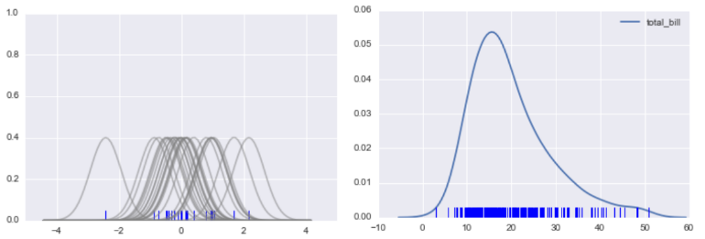

**CATEGORICAL PLOTS**

FACTORPLOT: sns.factorplot(x='sex',y='total_bill',data=tips,kind='bar')

BAR PLOTS

sns.barplot(x='sex',y='total_bill',data=tips,estimator=np.std)

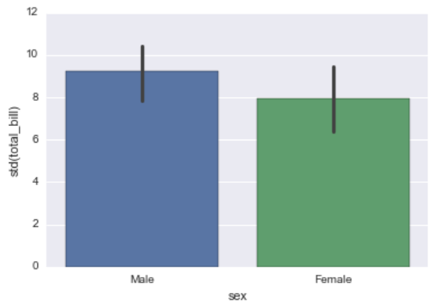

COUNT PLOTS

sns.countplot(x='sex',data=tips)

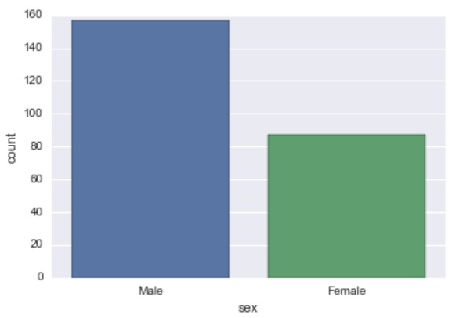

BOX PLOTS

sns.boxplot(x="day", y="total_bill", hue="smoker",data=tips, palette="coolwarm")

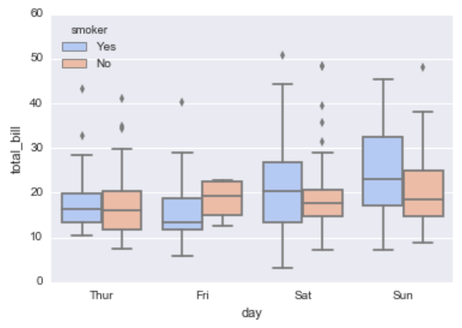

sns.boxplot(data=tips,palette='rainbow',orient='h')

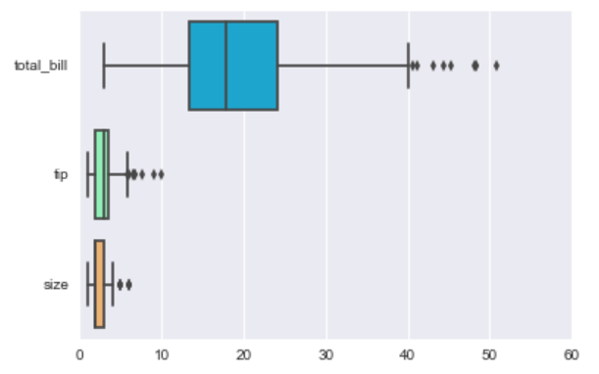

VIOLIN PLOTS

sns.violinplot(x="day", y="total_bill", data=tips,hue='sex',split=True,palette='Set1')

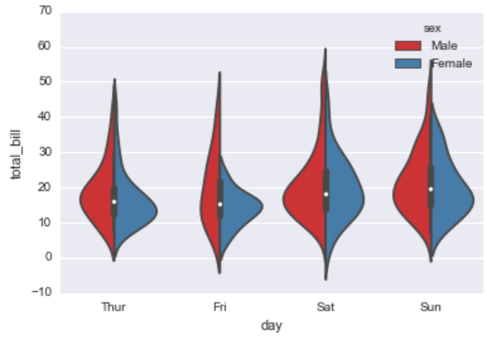

STRIP PLOTS

sns.stripplot(x="day", y="total_bill", data=tips,jitter=True,hue='sex',palette='Set1',split=True)

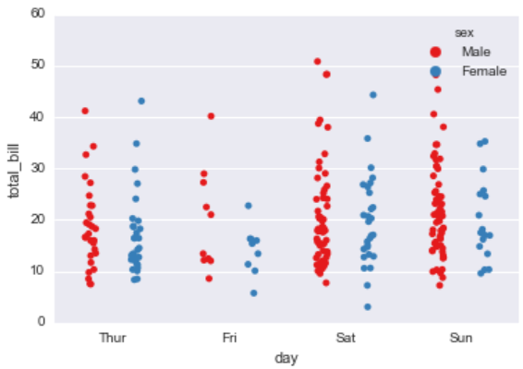

SWARM PLOTS

sns.swarmplot(x="day", y="total_bill",hue='sex',data=tips, palette="Set1", split=True)

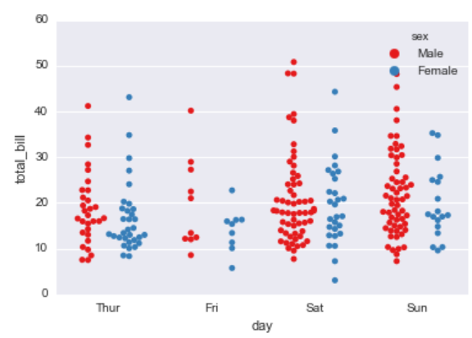

COMBINING:

sns.violinplot(x="tip", y="day", data=tips, palette='rainbow')

sns.swarmplot(x="tip", y="day", data=tips, color='black',size=3)

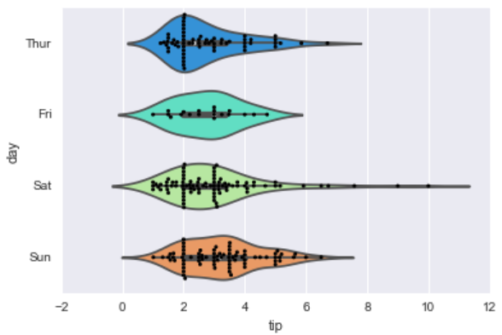

**MATRIX PLOTS**

HEAT MAP

sns.heatmap(tips.corr(),cmap='coolwarm',annot=True)

pvflights = flights.pivot_table(values='passengers', index='month', columns='year')

sns.heatmap(pvflights,cmap='magma',linecolor='white',linewidths=1)

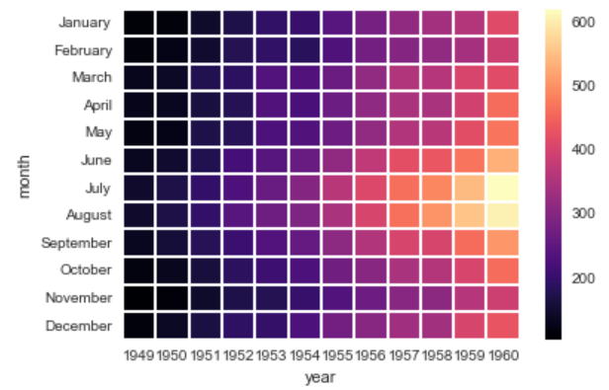

CLUSTER MAP

sns.clustermap(pvflights,cmap='coolwarm',standard_scale=1)

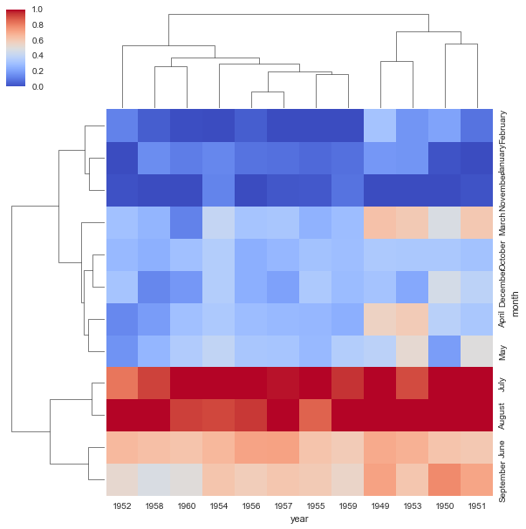

**GRIDS**

g = sns.PairGrid(DATAFRAME); g.map_diag(plt.hist)

g.map_upper(plt.scatter); g.map_lower(sns.kdeplot)

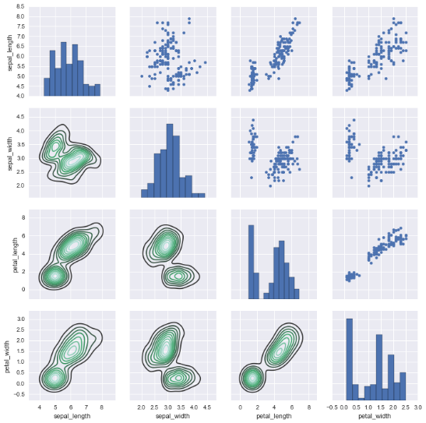

FACET GRID

g = sns.FacetGrid(data=tips, col="time", row="smoker",hue='sex')

g = g.map(plt.scatter, "total_bill", "tip").add_legend()

#g.map(plt.hist, "total_bill", "tip")

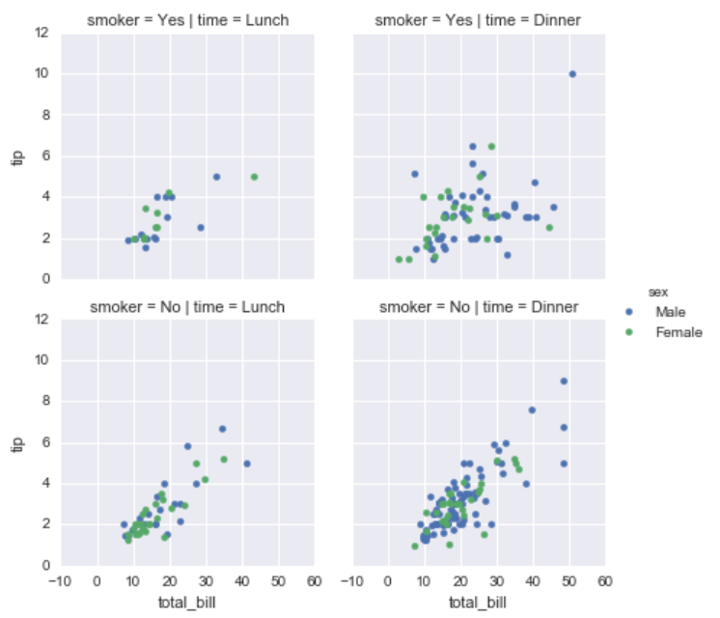

**MATRIX PLOTS**

REGRESSION PLOTS

sns.lmplot(x='total_bill',y='tip',data=tips,hue='sex',palette='coolwarm', markers=['o','v'],scatter_kws={'s':100})

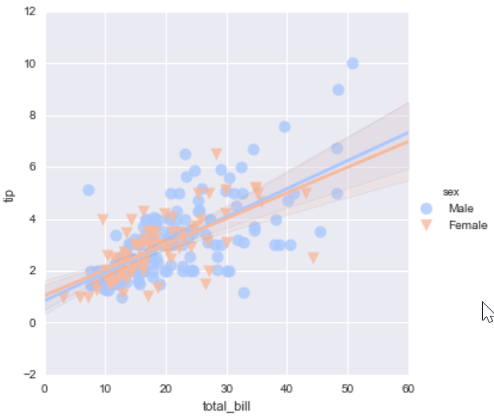

sns.lmplot(x="total_bill", y="tip", row="sex", col="time",data=tips)

# aspect=0.6, size=8

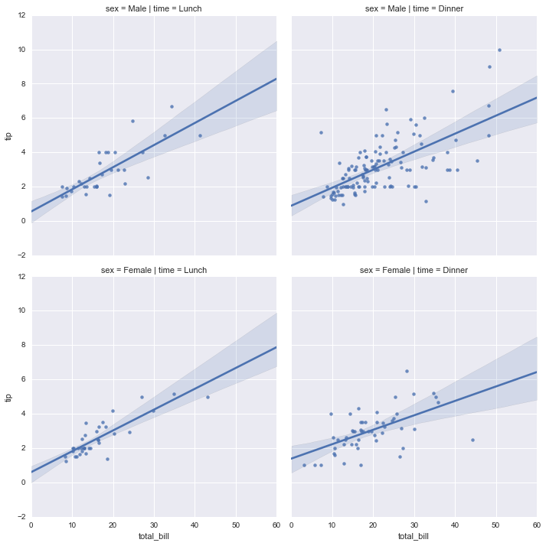

**STYLE**

sns.set_style('white')

# changes background color

# white, dark, ticks…

sns.despine(left=True)

# removes spines (lines that delimit the graph

sns.set_context('poster',font_scale=4)

# choose from context to improve visualization